[Home](https://www.electronics-tutorials.ws/) / [AC Circuits](https://www.electronics-tutorials.ws/category/accircuits) / Series Resonance Circuit



**Series Resonance Circuit**

Thus far we have analysed the behaviour of a series RLC circuit whose source voltage is a xed frequency steady state sinusoidal supply.

We have also seen in our tutorial about series RLC circuits that two or more sinusoidal signals can be combined using phasors providing that they have the same frequency supply.

But what would happen to the characteristics of the circuit if a supply voltage of xed amplitude but of different frequencies was applied to the circuit. Also what would the circuits “frequency response” behaviour be upon the two reactive components due to this varying frequency.

In a series RLC circuit there becomes a frequency point were the inductive reactance of the inductor becomes equal in value to the capacitive reactance of the capacitor. In other words, XL = XC. The point at which this occurs is called the **Resonant Frequency** point, ( **ƒ**r ) of the circuit, and as we are analysing a series RLC circuit this resonance frequency produces a **Series Resonance**.

***Series Resonance*** circuits are one of the most important circuits used electrical and electronic circuits. They can be found in various forms such as in AC mains lters,noise lters and also in radio and television tuning circuits producing a very selective tuning circuit for the receiving of the different frequency channels. Consider the simple series RLC circuit below.

**Series RLC Circuit**

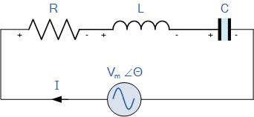

Firstly, let us de ne what we already know about series RLC circuits.

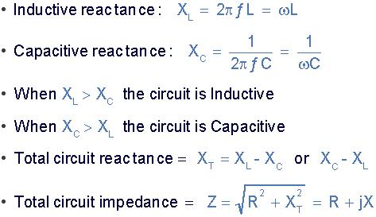

We use cookies to enhance your experience. By continuing to visit this site you agree to our use of cookies. [More info](http://wikipedia.org/wiki/HTTP_cookie)



From the above equation for inductive reactance, if either the **Frequency** or the **Inductance** is increased the overall inductive reactance value of the inductor would also increase. As the frequency approaches in nity the inductors reactance would also increase towards in nity with the circuit element acting like an open circuit.

However, as the frequency approaches zero or DC, the inductors reactance would decrease to zero, causing the opposite effect acting like a short circuit. This means then that inductive reactance is “**Proportional**” to frequency and is small at low frequencies and high at higher frequencies and this demonstrated in the following curve:

**Inductive Reactance against Frequency**

The graph of inductive reactance against frequency is a straight line linear curve. The inductive reactance value of an inductor increases linearly as the frequency across it increases. Therefore, inductive reactance is positive and is directly proportional to frequency ( XL ∝ **ƒ** )

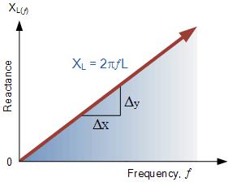

The same is also true for the capacitive reactance formula above but in reverse. If either the **Frequency** or the **Capacitance** is increased the overall capacitive reactance would decrease. As the frequency approaches in nity thecapacitors reactance would reduce to zero causing the circuit element to act like a perfect conductor of 0Ω’s.

But as the frequency approaches zero or DC level, the capacitors reactance would rapidly increase up to in nity causing it to act like a very large resistance acting like an open circuit condition. This means then that capacitive reactance is “**Inversely proportional**” to frequency for any given value of capacitance and this shown below:

**Capacitive Reactance against Frequency**

The graph of capacitive reactance against frequency is a hyperbolic curve. The Reactance value of a capacitor has a very high value at low frequencies but quickly decreases as the frequency across it increases. Therefore, capacitive reactance is negative and is inversely proportional to frequency ( XC ∝ **ƒ** -1 )

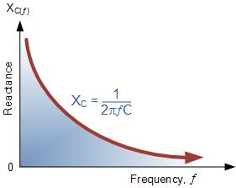

We can see that the values of these resistances depends upon the frequency of the supply. At a higher frequency XL is high and at a low frequency XC is high. Then there must be a frequency point were the value of XL is the same as the value of XC and there is. If we now place the curve for inductive reactance on top of the curve for capacitive reactance so that both curves are on the same axes, the point of intersection will give us the series resonance frequency point, ( **ƒ**r or ωr ) as shown below.

**Series Resonance Frequency**

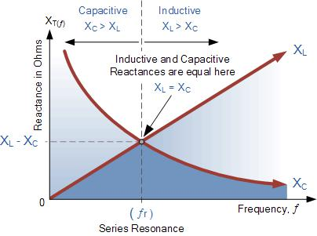

where: **ƒ**r is in Hertz, L is in Henries and C is in Farads.

Electrical resonance occurs in an AC circuit when the two reactances which are opposite and equal cancel each other out as XL = XC and the point on the graph at which this happens is were the two reactance curves cross each other. In a series resonant circuit, the resonant frequency, **ƒ**r point can be calculated as follows.

We use cookies to enhance your experience. By continuing to visit this site you agree to our use of cookies. [More info](http://wikipedia.org/wiki/HTTP_cookie)



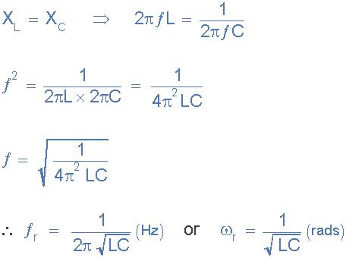

We can see then that at resonance, the two reactances cancel each other out thereby making a series LC combination act as a short circuit with the only opposition to current ow in a series resonance circuit being the resistance, R. In complex form, the resonant frequency is the frequency at which the total impedance of a series RLC circuit becomes purely ***“real”***, that is no imaginary impedance’s exist. This is because at resonance they are cancelled out. So the total impedance of the series circuit becomes just the value of the resistance and therefore: Z = R.

Then at resonance the impedance of the series circuit is at its minimum value and equal only to the resistance, R of the circuit. The circuit impedance at resonance is called the “dynamic impedance” of the circuit and depending upon the frequency, XC (typically at high frequencies) or XL (typically at low frequencies) will dominate either side of resonance as shown below.

**Impedance in a Series Resonance Circuit**

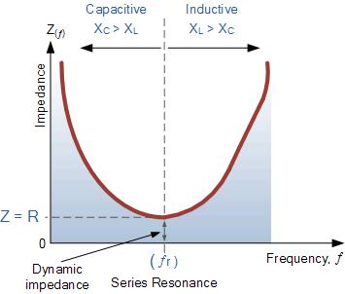

Note that when the capacitive reactance dominates the circuit the impedance curve has a hyperbolic shape to itself, but when the inductive reactance dominates the circuit the curve is non-symmetrical due to the linear response of XL. You may also note that if the circuits impedance is at its minimum at resonance then consequently, the circuits **admittance** must be at its maximum and one of the characteristics of a series resonance circuit is that admittance is very high. But this can be a bad thing because a very low value of resistance at resonance means that the resulting current owing through the circuit may be dangerously high.

We recall from the previous tutorial about series RLC circuits that the voltage across a series combination is the phasor sum of VR, VL and VC. Then if at resonance the two reactances are equal and cancelling, the two voltages representing VL and VC must also be opposite and equal in value thereby cancelling each other out because with pure components the phasor voltages are drawn at +90o and -90o respectively.

Then in a **series resonance** circuit as VL = -VC the resulting reactive voltages are zero and all the supply voltage is dropped across the resistor. Therefore,

VR = Vsupply and it is for this reason that series resonance circuits are known as voltage resonance circuits, (as opposed to parallel resonance circuits which are current resonance circuits).

**Series RLC Circuit at Resonance**

We use cookies to enhance your experience. By continuing to visit this site you agree to our use of cookies. [More info](http://wikipedia.org/wiki/HTTP_cookie)



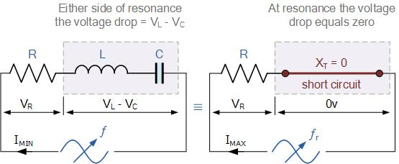

Since the current owing through a series resonance circuit is the product of voltage divided by impedance, at resonance the impedance, Z is at its minimum value, ( =R ). Therefore, the circuit current at this frequency will be at its maximum value of V/R as shown below.

**Series Circuit Current at Resonance**

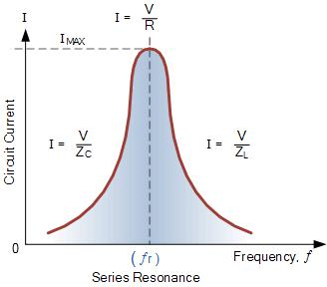

The frequency response curve of a series resonance circuit shows that the magnitude of the current is a function of frequency and plotting this onto a graph shows us that the response starts at near to zero, reaches maximum value at the resonance frequency when IMAX = IR and then drops again to nearly zero as **ƒ** becomes in nite. The result of this is that the magnitudes of the voltages across the inductor, L and the capacitor, C can become many times larger than the supply voltage, even at resonance but as they are equal and at opposition they cancel each other out.

As a series resonance circuit only functions on resonant frequency, this type of circuit is also known as an **Acceptor Circuit** because at resonance, the impedance of the circuit is at its minimum so easily accepts the current whose frequency is equal to its resonant frequency.

You may also notice that as the maximum current through the circuit at resonance is limited only by the value of the resistance (a pure and real value), the source voltage and circuit current must therefore be in phase with each other at this frequency. Then the phase angle between the voltage and current of a series resonance circuit is also a function of frequency for a xed supply voltage and which is zero at the resonant frequency point when: V, I and VR are all in phase with each other as shown below. Consequently, if the phase angle is zero then the power factor must therefore be unity.

**Phase Angle of a Series Resonance Circuit**

We use cookies to enhance your experience. By continuing to visit this site you agree to our use of cookies. [More info](http://wikipedia.org/wiki/HTTP_cookie)



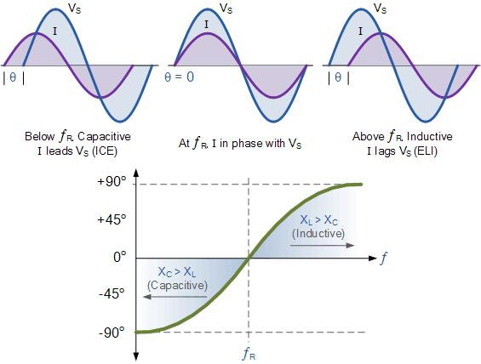

Notice also, that the phase angle is positive for frequencies above **ƒ**r and negative for frequencies below **ƒ**r and this can be proven by,



**Bandwidth of a Series Resonance Circuit**

If the series RLC circuit is driven by a variable frequency at a constant voltage, then the magnitude of the current, I is proportional to the impedance, Z, therefore at resonance the power absorbed by the circuit must be at its maximum value as P = I2Z.

If we now reduce or increase the frequency until the average power absorbed by the resistor in the series resonance circuit is half that of its maximum value at resonance, we produce two frequency points called the **half-power points** which are -3dB down from maximum, taking 0dB as the maximum current reference.

These -3dB points give us a current value that is 70.7% of its maximum resonant value which is de ned as: 0.5( I2 R ) = (0.707 x I)2 R. Then the point corresponding to the lower frequency at half the power is called the “lower cut-off frequency”, labelled **ƒ**L with the point corresponding to the upper frequency at half power being called the “upper cut-off frequency”, labelled **ƒ**H. The distance between these two points, i.e. ( **ƒ**H – **ƒ**L ) is called the **Bandwidth**, (BW) and is the range of frequencies over which at least half of the maximum power and current is provided as shown.

**Bandwidth of a Series Resonance Circuit**

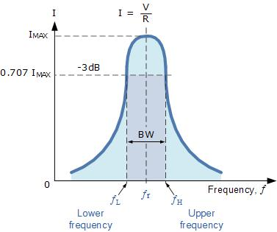

The frequency response of the circuits current magnitude above, relates to the “sharpness” of the resonance in a series resonance circuit. The sharpness of the peak is measured quantitatively and is called the **Quality factor, Q** of the circuit. The quality factor relates the maximum or peak energy stored in the circuit (the reactance) to the energy dissipated (the resistance) during each cycle of oscillation meaning that it is a ratio of resonant frequency to bandwidth and the higher the circuit Q, the smaller the bandwidth, Q = **ƒ**r /BW.

We use cookies to enhance your experience. By continuing to visit this site you agree to our use of cookies. [More info](http://wikipedia.org/wiki/HTTP_cookie)



As the bandwidth is taken between the two -3dB points, the **selectivity** of the circuit is a measure of its ability to reject any frequencies either side of these points. A more selective circuit will have a narrower bandwidth whereas a less selective circuit will have a wider bandwidth. The selectivity of a series resonance circuit can be controlled by adjusting the value of the resistance only, keeping all the other components the same, since Q = (XL or XC)/R.

**Bandwidth of a Series RLC Resonance Circuit**

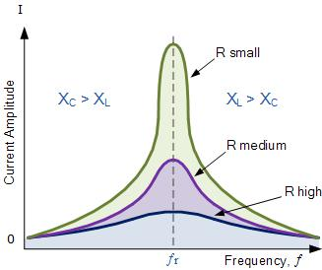

Then the relationship between resonance, bandwidth, selectivity and quality factor for a series resonance circuit being de ned as:

1). Resonant Frequency, (**ƒ**r)

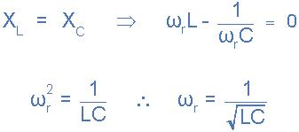

2). Current, (I)

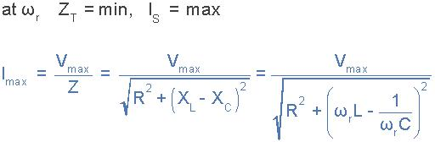

3). Lower cut-off frequency, (**ƒ**L)

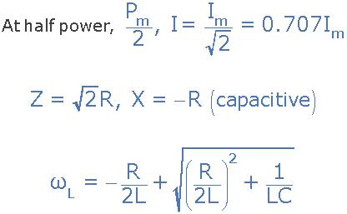

4). Upper cut-off frequency, (**ƒ**H)

We use cookies to enhance your experience. By continuing to visit this site you agree to our use of cookies. [More info](http://wikipedia.org/wiki/HTTP_cookie)



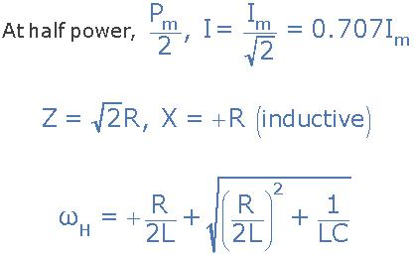

5). Bandwidth, (BW)



6). Quality Factor, (Q)

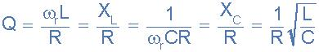

**Series Resonance Example No1**

A series resonance network consisting of a resistor of 30Ω, a capacitor of 2uF and an inductor of 20mH is connected across a sinusoidal supply voltage which has a constant output of 9 volts at all frequencies. Calculate, the resonant frequency, the current at resonance, the voltage across the inductor and capacitor at resonance, the quality factor and the bandwidth of the circuit. Also sketch the corresponding current waveform for all frequencies.

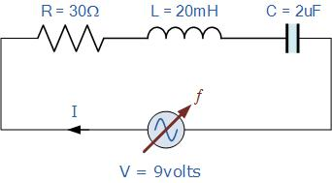

Resonant Frequency, **ƒ**r

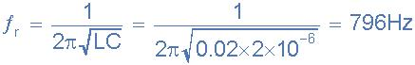

Circuit Current at Resonance, Im



Inductive Reactance at Resonance, XL



Voltages across the inductor and the capacitor, VL, VC

We use cookies to enhance your experience. By continuing to visit this site you agree to our use of cookies. [More info](http://wikipedia.org/wiki/HTTP_cookie)



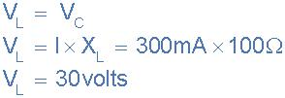

Note: the supply voltage may be only 9 volts, but at resonance, the reactive voltages across the capacitor, VC and the inductor, VL are 30 volts peak! Quality factor, Q



Bandwidth, BW



The upper and lower -3dB frequency points, **ƒ**H and **ƒ**L

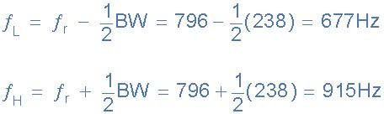

Current Waveform

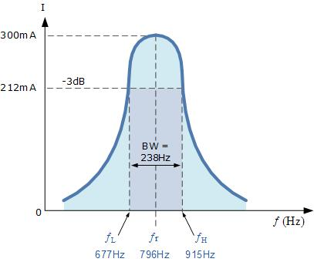

**Series Resonance Example No2**

A series circuit consists of a resistance of 4Ω, an inductance of 500mH and a variable capacitance connected across a 100V, 50Hz supply. Calculate the capacitance require to produce a series resonance condition, and the voltages generated across both the inductor and the capacitor at the point of resonance.

Resonant Frequency, **ƒ**r

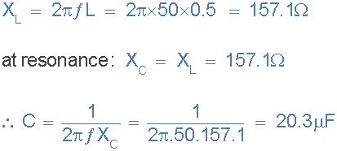

Voltages across the inductor and the capacitor, V , V

We use cookies to enhance your experienceLC. By continuing to visit this site you agree to our use of cookies. [More info](http://wikipedia.org/wiki/HTTP_cookie)



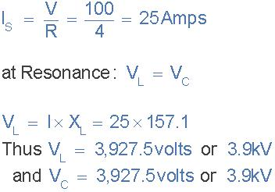

**Series Resonance Summary**

You may have noticed that during the analysis of series resonance circuits in this tutorial, we looked at bandwidth, upper and lower frequencies, -3dB points and quality or Q-factor. All these are terms used in designing and building of Band Pass Filters (BPF) and indeed, resonance circuits are used in 3-element mains lter designs to pass all frequencies within the “passband” range while rejecting all others.

However, the main aim of this tutorial is to analyse and understand the concept of how **Series Resonance** occurs in passive RLC series circuits. Their use in RLC lter networks and designs is outside the scope of this particular tutorial, and so will not be looked at here, sorry.

For resonance to occur in any circuit it must have at least one inductor and one capacitor.



Resonance is the result of oscillations in a circuit as stored energy is passed from the inductor to the capacitor.



Resonance occurs when XL = XC and the imaginary part of the transfer function is zero.



At resonance the impedance of the circuit is equal to the resistance value as Z = R.



At low frequencies the series circuit is capacitive as: XC > XL, this gives the circuit a leading power factor.



At high frequencies the series circuit is inductive as: XL > XC, this gives the circuit a lagging power factor.



The high value of current at resonance produces very high values of voltage across the inductor and capacitor.



Series resonance circuits are useful for constructing highly frequency selective lters. However, its high current and very high component voltage values can cause damage to the circuit.



The most prominent feature of the frequency response of a resonant circuit is a sharp resonant peak in its amplitude characteristics.



Because impedance is minimum and current is maximum, series resonance circuits are also called **Acceptor Circuits**.



In the next tutorial about Parallel Resonance we will look at how frequency affects the characteristics of a parallel connected RLC circuit and how this time the Q-factor of a parallel resonant circuit determines its current magni cation.

**103 Comments**



Join the conversation!



Your Name



Email Address

We use cookies to enhance your experience. By continuing to visit this site you agree to our use of cookies. [More info](http://wikipedia.org/wiki/HTTP_cookie)



Write your comment here

SUBMIT

* Pierre

I want some help please.

Posted on January 16th 2018 | 5:16 pm

[Reply](https://www.electronics-tutorials.ws/accircuits/series-resonance.html?replytocom=47334#respond)



* RAHIM

hi…

i wonder does the current at resonance equal tu peak current across the resistor or it is equal to root mean square current across resistor

Posted on December 27th 2017 | 2:27 am

[Reply](https://www.electronics-tutorials.ws/accircuits/series-resonance.html?replytocom=45585#respond)



* Colline

Could you help me to work out why the dynamic impedance increases as the LC ratio changes.at 7 megahertz if you have 14pf and around 30microheneries the dynamic Z is around 20 ohms but if you make C smaller and L 60 microheneries the Dynamic Z is over 100 ohms. Why is this please.

Posted on December 18th 2017 | 10:13 pm

[Reply](https://www.electronics-tutorials.ws/accircuits/series-resonance.html?replytocom=44972#respond)



* Deepak Srivastava

Very nice…

Great explanation

Posted on December 15th 2017 | 1:42 pm



* Sandy Cheeks

I like Bread ngers

Posted on December 11th 2017 | 11:48 am

We use cookies to enhance your experience. By continuing to visit this site you agree to our use of cookies. [More info](http://wikipedia.org/wiki/HTTP_cookie)

[Reply](https://www.electronics-tutorials.ws/accircuits/series-resonance.html?replytocom=44696#respond)

[Reply](https://www.electronics-tutorials.ws/accircuits/series-resonance.html?replytocom=44325#respond)



* Govind

Thanks..

Posted on December 07th 2017 | 3:06 am

[Reply](https://www.electronics-tutorials.ws/accircuits/series-resonance.html?replytocom=43874#respond)



* Muhammad Ali Haider

Very nice article, learned a lot from it but still have confusion in Half power frequencies.

Posted on December 04th 2017 | 2:33 pm

[Reply](https://www.electronics-tutorials.ws/accircuits/series-resonance.html?replytocom=43583#respond)



* Sebastian

thank you very much you just saved me from failing

Posted on November 29th 2017 | 11:36 pm

[Reply](https://www.electronics-tutorials.ws/accircuits/series-resonance.html?replytocom=43063#respond)



* Bharathi

nice explanation

Posted on November 23rd 2017 | 12:23 pm

[Reply](https://www.electronics-tutorials.ws/accircuits/series-resonance.html?replytocom=42169#respond)



* BharathI

Nice

Posted on November 23rd 2017 | 12:21 pm

[Reply](https://www.electronics-tutorials.ws/accircuits/series-resonance.html?replytocom=42168#respond)



[View More](https://www.electronics-tutorials.ws/accircuits/series-resonance.html/comment-page-2#comments)

We use cookies to enhance your experience. By continuing to visit this site you agree to our use of cookies. [More info](http://wikipedia.org/wiki/HTTP_cookie)

